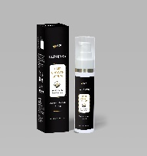
PRODUCT NAME: KERAJAKS HAIR SERUM
INCI: Redensyl™ + Procapil™ + AnaGainTM

- DESCRIPTION:
Kerajaks is a formulation that is serum-based and enhanced by the potency of natural components. Its irritation-free solution, which has been rigorously tested on both men and women, encourages quick hair growth while nourishing the scalp. It strengthens hair from root to tip and tackles the primary causes of hair loss. Kerajaks is enhanced with natural components, such as:
- RedensylTM, a patented plant-based formulation that acts as a calming, anti-hairloss, and hair-beautifying agent.
- ProcapilTM is a patented plant-based solution that naturally strengthens hair and stops hair loss.
- AnaGainTM is an extract of Pisum sativum (pea) sprout that helps to prevent hair loss and promotes natural hair growth by extending the life cycle of hair and assisting in the restoration of hair vitality.

- THERAPY AREA: Trichology

PACKAGING: 60 ml Bottle
COMPOSITION: Redensyl™ + Procapil™ + AnaGainTM

INDICATIONS:

Telogen Effluvium, Androgenetic alopecia, Re-densification of Hair on Scalp, Male pattern hair loss

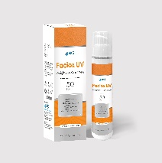
PRODUCT NAME: FACIOX UV
INCI: Micronized Zinc Oxide, Micronized Titanium Dioxide, Caesalpinia Spinosa Fruit Pod Extract, Propylene Glycol, Helianthus Annuus (Sunflower) Sprout Extract, Sodium Hyaluronate, Vitamin C

- DESCRIPTION:
Faciox UV is a smart sunscreen that provides ultimate defence against harmful UV rays. Faciox UV comprises of Micronized Zinc Oxide, Micronized Titanium Dioxide, Caesalpinia Spinosa Fruit Pod Extract, Helianthus Annuus (Sunflower) Sprout Extract, Tocopheryl acetate and dimethicone crosspolymers. Faciox UV provide protection against:

- UV-A rays
- UV-B rays
- Anti-Pollution
- Blocks IR and blue light-induced free radical formation
- Protects mitochondrial DNA
- Inhibits light-induced skin aging
- Prevents the loss of skin density upon sun exposure

It is a silicone-based water-resistant formula with SPF 50 and PA+++ sunscreen that creates breathable barrier to the skin, provides hydrating effect and excellent spreadability properties.

- THERAPY AREA: Dermatology

PACKAGING: 50 ml Bottle
COMPOSITION: Micronized Zinc Oxide, Micronized Titanium Dioxide, Caesalpinia Spinosa Fruit Pod Extract (and) Propylene Glycol (and) Helianthus Annuus (Sunflower) Sprout Extract

INDICATIONS:

Anti-UV+ IR+ Blue Light, Anti-Pollution, Broad Spectrum Protection, Sunburn, SunTan, Premature Ageing

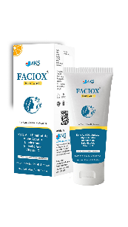
PRODUCT NAME: FACIOX FACE WASH
INCI: Kojic Acid Dipalmitate, Alpha Arbutin, Niacinamide, Salicylic Acid

- DESCRIPTION:
Discover the secret to radiant, flawless skin with FACIOX Face Wash, a cutting-edge skincare solution formulated with a powerhouse blend of ingredients. FACIOX Face wash comprises with the skin-loving benefits of Kojic Acid Dipalmitate, Alpha Arbutin, Niacinamide, Salicylic Acid & Vitamin C to give a comprehensive skincare experience like no other.

- Kojic Acid Dipalmitate: Known for its skin-brightening properties, Kojic Acid Dipalmitate helps reduce the appearance of dark spots, age spots, and uneven skin tone. It's the key to achieving a luminous complexion.

- Alpha Arbutin: A gentle yet effective skin lightening agent, Alpha Arbutin works to fade discolorations, leaving your skin looking more even and youthful.

- Niacinamide: This multi-tasking ingredient is a true skincare superhero. Niacinamide, also known as Vitamin B₃, enhances skin hydration, improves texture, and helps to reduce the appearance of fine lines and wrinkles.

- Salicylic Acid: Perfect for those prone to breakouts, Salicylic Acid exfoliates and unclogs pores, keeping acne at bay and leaving the skin smoother and clearer.

- THERAPY AREA: Dermatology

PACKAGING: 70 gm Tube
COMPOSITION: Kojic Acid Dipalmitate, Alpha Arbutin, Niacinamide,Salicylic Acid

INDICATIONS:

Uneven Skin Tone, Melasma, Acne, Hyperpigmentation, Skin Radiance, Oily skin

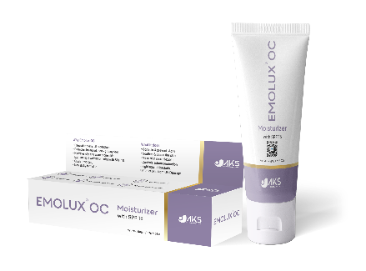

PRODUCT NAME: EMOLUX OC
INCI: Ceramides, Sodium Hyaluronate, Lecithin

- DESCRIPTION:
Emolux OC is an oil control moisturizer with SPF 15 for oily and sensitive skin. Emolux Oil Control Moisturizer is a gateway for achieving a complexion that is not only hydrated but also perfectly balanced. Formulated with a harmonious trio of Ceramides, Sodium Hyaluronate, and Lecithin, this advanced skincare product offers the ultimate solution for oil-prone skin types.
Key Ingredients:
- Ceramides: These natural lipids are the building blocks of a healthy skin barrier. Ceramides help the skin retain moisture, fortify its protective barrier, and keep irritants at bay, ensuring a radiant and well-protected complexion.
- Sodium Hyaluronate: A powerhouse ingredient renowned for its ability to attract and retain moisture, Sodium Hyaluronate hydrates the skin at a deeper level. This results in a plump and youthful appearance, diminishing the appearance of fine lines and wrinkles.
- Lecithin: Lecithin plays a vital role in maintaining skin health. It helps regulate the skin's oil production, promoting a balanced, non-greasy feel, while also contributing to improved skin texture and overall appearance.

- THERAPY AREA: Dermatology

PACKAGING: 50 ml Bottle
COMPOSITION: Ceramides, Sodium Hyaluronate, Lecithin

INDICATIONS:

Uneven Skin Tone, Melasma, Acne, Hyperpigmentation, Skin Radiance, Oily skin

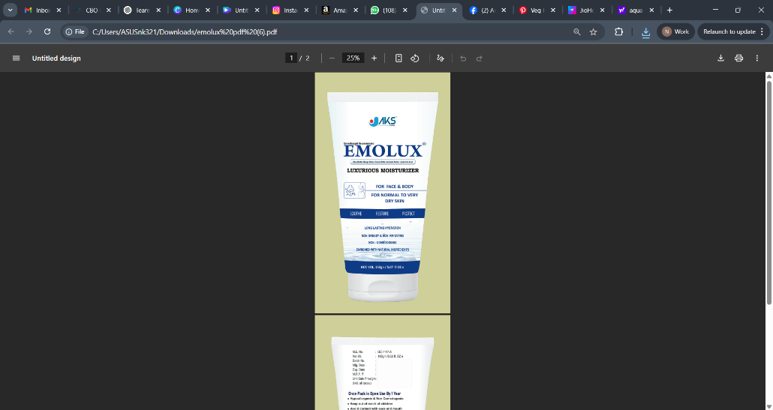
+PRODUCT NAME: EMOLUX MOIST
INCI: Shea Butter, Mango Butter, Cocoa Butter, Avocado Butter, Sodium Hyaluronate

- DESCRIPTION:
Emolux Moist Moisturizer is a testament to the power of nature's most sumptuous ingredients. This advanced skincare product is crafted with a rich blend of Shea Butter, Mango Butter, Cocoa Butter, and Avocado Butter, offering skin an opulent experience in hydration and nourishment.
Key Ingredients:
- Shea Butter: Renowned for its exceptional moisturizing properties, Shea Butter deeply nourishes the skin, helping to lock in moisture and leaving it soft, smooth, and supple.
- Mango Butter: This butter is a treasure trove of antioxidants and vitamins, providing the skin with protection against environmental stressors, while also offering soothing relief and hydration.
- Cocoa Butter: Known for its indulgent texture, Cocoa Butter assists in improving skin elasticity and firmness. It's an excellent choice for those seeking to reduce the appearance of stretch marks and scars.
- Avocado Butter: Packed with essential fatty acids, Avocado Butter hydrates and rejuvenates the skin, leaving it with a natural glow and improved overall health.
Benefits of Emolux Moist Moisturizer:
- Intensive Hydration
- Skin Restoration
- Protection and Soothing
- Improved Elasticity
- Radiant Glow
Emolux Moist Moisturizer is a celebration of skin pampering at its finest. Experience the lush, hydrating embrace of our natural butter blend, and indulge in the transformation of your skin.

PACKAGING: 50 ml Bottle
COMPOSITION: Shea Butter, Mango Butter, Cocoa Butter, Avocado Butte

INDICATIONS:

Xerosis, Dry Skin, Itchy Skin, Eczema, atopic skin
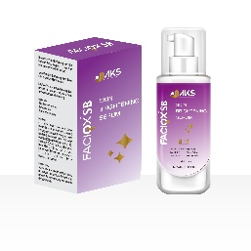
PRODUCT NAME: FACIOX SKIN BRIGHTENING SERUM
INCI: Melanostatine™, Tyrostat™, ß-White™, Kojic acid, alpha arbutin, Niacinamide

- DESCRIPTION:
FACIOX Skin Brightening Serum is key to unlocking a luminous, even-toned complexion. Crafted with a potent blend of cutting-edge ingredients, including Melanostatine™, Tyrostat™, and ß-White™, this advanced serum is designed to transform the skin and reveal its natural radiance.
Key Ingredients:
- Melanostatine™: This powerful ingredient is known for its ability to inhibit melanin production, reducing the appearance of dark spots and hyperpigmentation. It's the secret to achieving a brighter, more uniform skin tone.
- Tyrostat™: Tyrostat™ is a key player in the fight against uneven skin tone. It helps regulate the melanin production process, ensuring that your skin's pigmentation remains balanced and harmonious.
- ß-White™: A skin-brightening superstar, ß-White™ is renowned for its ability to reduce discolorations and enhance the overall radiance of the skin.
Benefits of FACIOX Skin Brightening Serum:
- Luminous Complexion
- Even Skin Tone
- Hyperpigmentation Reduction
- Skin Vitality

- THERAPY AREA: Dermatology

PACKAGING: 30 ml Bottle
COMPOSITION: Melanostatine™, Tyrostat™, ß-White™, Kojic acid, alpha arbutin, Niacinamide

INDICATIONS:

Hyperpigmentation, uneven skin tone, Melasma, Skin Radiance, Photoageing, Post-inflammatory hyperpigmentation (PIH)

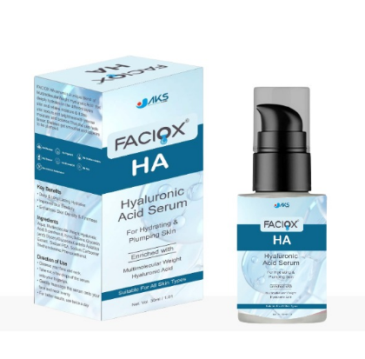
PRODUCT NAME: FACIOX HA SERUM
INCI: Multimolecular Hyaluronic acid

- DESCRIPTION:
FACIOX HA Serum is your secret to achieving plump, hydrated, and radiant skin. Formulated with the powerhouse ingredient, Multimolecular Hyaluronic Acid, this advanced serum is designed to provide deep and multi-layered hydration for your skin, leaving you with a complexion that's nothing short of luminous.
Key Ingredient:
- Multimolecular Hyaluronic Acid: This exceptional form of hyaluronic acid comes in various molecular sizes, enabling it to deliver moisture to different layers of the skin. It not only hydrates the surface but penetrates deeper, creating a reservoir of hydration for long-lasting results.
Benefits of FACIOX HA Serum:
- Intensive Hydration
- Smooth and Supple Skin
- Enhanced Skin Elasticity
- Best for post procedure skin

Join the journey to healthier, more beautiful skin with FACIOX HA Serum today. Unleash the power of deep and multi-layered hydration for a complexion that's truly luminous.

- THERAPY AREA: Dermatology

PACKAGING: 30 ml Bottle
COMPOSITION: Multimolecular Hyaluronic acid

INDICATIONS:

Wrinkles, Fine lines, Premature Ageing, Dry skin

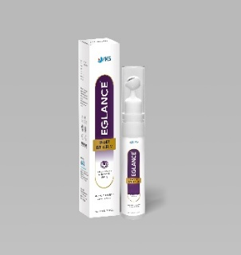
PRODUCT NAME: EGLANCE UNDER EYE SERUM
INCI: ADIPOLESS™, Retinol,Caffeine, Squalene, Hyaluronic acid

- DESCRIPTION:
EGLANCE Under Eye Serum is key to transforming tired, puffy under-eye areas into a radiant and rejuvenated masterpiece. Formulated with a dynamic blend of ingredients, including ADIPOLESS™, Retinol, Caffeine, and Squalene, this advanced serum is designed to target under-eye concerns and bring back the youthful sparkle to your eyes.
Key Ingredients:
- ADIPOLESS™: ADIPOLESS™ is a remarkable ingredient known for its ability to reduce the appearance of under-eye bags and puffiness. It helps promote a smoother, more refreshed look.
- Retinol: A powerhouse in the world of skincare, Retinol helps to improve skin texture and diminish the appearance of fine lines and wrinkles, leaving your under-eye area looking more youthful.
- Caffeine: Caffeine provides an instant pick-me-up for tired eyes by reducing puffiness and promoting improved blood circulation. It's your secret weapon against morning eye fatigue.
- Squalene: Squalene is a highly effective hydrator that aids in maintaining the delicate under-eye skin's moisture balance, ensuring it remains soft and supple.
Benefits of EGLANCE Under Eye Serum:
- Puffiness Reduction
- Youthful Radiance
- Instant Refreshment
- Hydrated Skin
- Gentle and Effective

PACKAGING: 10 ml Bottle
COMPOSITION: ADIPOLESS™, Retinol, Caffeine, Squalene

INDICATIONS: Dark circles, Crow’s feet and puffiness

PRODUCT NAME: FACIOX VITAMIN C SERUM
INCI: 3-O-ethyl-ascorbic acid, Ascorbyl glucoside

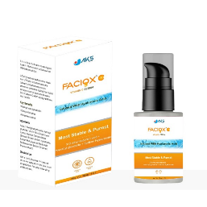
- DESCRIPTION:
FACIOX Vitamin C Serum is ticket to achieving a radiant and revitalized complexion. Formulated with the powerful combination of 3-O-Ethyl Ascorbic Acid and Ascorbyl Glucoside, Sodium Hyaluronate.
This advanced serum is designed to target a range of skin concerns, from brightening and firming to protecting skin against environmental stressors.

Key Ingredients:

- 3-O-Ethyl Ascorbic Acid: This form of Vitamin C is a stable and highly effective antioxidant, known for its ability to brighten the skin, reduce the appearance of dark spots, and promote a more even skin tone.

- Ascorbyl Glucoside: Ascorbyl Glucoside is another potent form of Vitamin C that not only offers antioxidant protection but also helps to improve skin hydration, boost collagen production, and reduce the signs of aging.

Join the journey to healthier, more beautiful skin with FACIOX Vitamin C Serum today. Reveal natural radiance and embrace the confidence that comes with a revitalized and luminous appearance.

- THERAPY AREA: Dermatology

PACKAGING: 30 ml Bottle
COMPOSITION: 3-O-ethyl-ascorbic acid, Ascorbyl glucoside, Sodium Hyaluronate

INDICATIONS:

Wrinkles, Hyperpigmentation, Premature Ageing, Crow's Feet

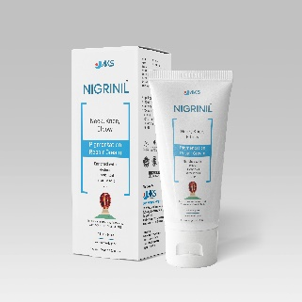
PRODUCT NAME: NIGRINIL CREAM
INCI: Retinol, Lactic Acid, Glycolic Acid, Urea, Sodium Hyaluronate

- DESCRIPTION:
Nigrinil Cream is a powerful skincare innovation specifically crafted to address the challenges of Acanthosis Nigricans while simultaneously rejuvenating your skin. Formulated with a potent blend of ingredients, including Retinol, Lactic Acid, Glycolic Acid, and Urea, this cream offers a multifaceted approach to skin renewal and the management of Acanthosis Nigricans.
Key Ingredients:
- Retinol: A trusted ingredient and first line treatment for acanthosis nigricans. Retinol helps reduce the appearance of hyperpigmentation and aids in skin cell turnover, revealing a smoother and more even complexion.
- Lactic Acid: Gentle yet effective exfoliant that targets the hyperkeratinization associated with Acanthosis Nigricans, helping to smooth and rejuvenate the affected areas.
- Glycolic Acid: An alpha hydroxy acid (AHA), works to refine skin texture, unclog pores, and reduce the appearance of dark patches, promoting an even skin tone.
- Urea: Provides deep hydration, helping to alleviate the dryness often associated with Acanthosis Nigricans and leaving your skin soft and well-nourished.
Benefits of Nigrinil Cream for Acanthosis Nigricans:
- Hyperpigmentation Reduction
- Gentle Exfoliation
- Deep Hydration
- Tailored for Sensitive Skin

PACKAGING: 100 gm Tube
COMPOSITION: Retinol, Lactic Acid, Glycolic Acid, Urea
INDICATIONS: Hyperpigmentation Associated with Acanthosis Nigricans, Post-Inflammatory Hyperpigmentation (PIH)

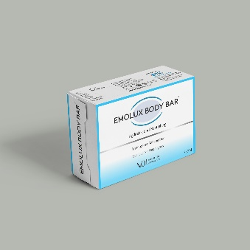

PRODUCT NAME: EMOLUX BODY BAR
INCI: Daucus Carota Sativa (Carrot) Seed Oil, Aloe Barbadensis (aloe vera) Extract, Vitamin E, Chamomilla Recutita (Matricaria) Flower Extract

- DESCRIPTION:
Emolux Body Bar is more than just soap; it's a luxurious experience designed to pamper your skin while harnessing the power of nature. Crafted with a harmonious blend of Daucus Carota Sativa (Carrot) Seed Oil, Aloe Barbadensis (Aloe Vera) Extract, Vitamin E, and Chamomilla Recutita (Matricaria) Flower Extract, this body bar offers a rejuvenating and revitalizing cleanse.
Key Ingredients:
- Carrot Seed Oil: Packed with antioxidants and vitamins, carrot seed oil is known for its skin-nourishing properties. It helps improve skin tone, elasticity, and provides deep hydration.
- Aloe Vera Extract: Soothing and hydrating powerhouse. It helps calm and moisturize your skin, leaving it refreshed and rejuvenated.
- Vitamin E: A potent antioxidant, Vitamin E fights free radicals, helping to reduce the signs of aging and promote smoother, healthier skin.
- Chamomile Flower Extract: Renowned for its calming and anti-inflammatory benefits, making it ideal for soothing sensitive or irritated skin.
Benefits of Emolux Body Bar:
- Hydrating Cleanse
- Soothing Sensation
- Antioxidant Protection
- Radiant skin
- Daily Indulgence

PACKAGING: 100 gm BAR
COMPOSITION: Daucus Carota Sativa (Carrot) Seed Oil, Aloe Barbadensis (aloe vera) Extract, Vitamin E, Chamomilla Recutita (Matricaria) Flower Extract

INDICATIONS:
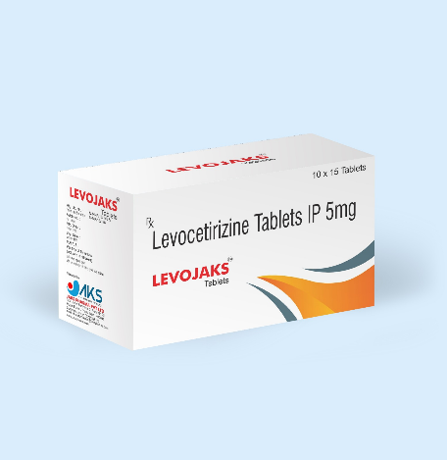
For general body dryness

PRODUCT NAME: LEVOAJAKS
INCI: Levocetrizine Tablets

- DESCRIPTION:
Levojaks is an anti-allergy formulation that contains Levocetrizine 5 mg / 10 mg in Tablet form. Elevate Your Skin's Resilience with Levojaks.

Welcome to a world where your skin's well-being takes center stage. Introducing Levojaks – a breakthrough in the prevention and treatment of allergic skin reactions.

Key Ingredients:
Levocetirizine is an H1-receptor antagonist used to treat symptoms associated with chronic allergic rhinitis and uncomplicated cases of chronic idiopathic urticaria.
It is a non-sedating, long acting H₁ receptor antagonist antihistamine for second generation with good efficacy and tolerability profile

- THERAPY AREA: Dermatology

PACKAGING: 1 x 15 TABLETS / 1 * 10 TABLETS
COMPOSITION: Levocetrizine
Get Fast-Track Relief & versatile protection with Levojaks : Say goodbye to prolonged suffering. Levojaks boasts a fast-acting formula, swiftly alleviating symptoms and restoring your skin to its natural, serene state.
From acute allergic reactions triggered by drugs, foods, or insect bites, to the recurring challenges of hay fever, Levojaks is your comprehensive solution. One tablet, multiple victories.

INDICATIONS:

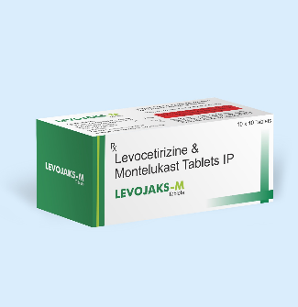
- Urticaria, Pruritus, Acute allergic reaction due to drug, food or insect bites & Acute Rhinitis
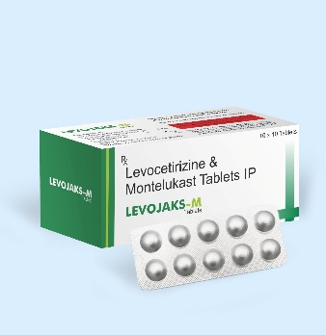

PRODUCT NAME: LEVOAJAKS M

INCI: Levocetrizine 5 mg + Monteleukast 10 mg Tablets

- DESCRIPTION:
Levojaks M is an anti-allergy formulation that contains Levocetrizine 5 mg & Montelukast 10 mg in Tablet form. Elevate Your Skin's Resilience with Levojaks M that are resistant to Levocetrizine only. The ultimate solution for allergic skin reactions.
Approved Fixed dose combination for Urticaria and allergic reactions
More effective in Fixed dose combination then the monotherapy of each ingredients. Has excellent safety profile without any potential side effects.

Introducing a Dynamic Duo: Levocetirizine + Montelukast

Key Ingredients:
Levocetirizine is an H1-receptor antagonist used to treat symptoms associated with chronic allergic rhinitis and uncomplicated cases of chronic idiopathic urticaria.
- Montelukast is a Leukotriene receptor antagonist that shows a marked selectivity and affinity to the cysteinyl leukotriene receptor type 1. Leukotrienes are potent proinflammatory mediators, and these effects can be blocked by Leukotriene receptor antagonists (LTRA).
- It was first approved for clinical use by the US FDA in 1998

PACKAGING: 1 x 10 TABLETS
COMPOSITION: Levocetrizine + Montelukast

.INDICATIONS:

- Urticaria, Pruritus, Acute allergic reaction due to drug, food or insect bites & Acute Rhinitis.

PRODUCT NAME: JAKSIT SB
INCI: Itraconazole Super Bioavailable Tablets -

- DESCRIPTION:
Unlocking the Power of Itraconazole Super Bioavailable

Embark on a journey to superior antifungal care with JAKSIT SB. This revolutionary formulation harnesses the potency of Itraconazole Super Bioavailable, setting a new standard in the fight against fungal infections. Welcome to a world where efficacy meets innovation, where JAKSIT SB stands as your trusted ally in reclaiming healthy, fungi-free skin.

Key Ingredients:

Experience the JAKSIT SB Advantage:
- Superior Bioavailability: Our commitment to cutting-edge science ensures that each dose of JAKSIT SB delivers potent antifungal action, optimizing your path to recovery.
- Proven Efficacy: Backed by clinical research, JAKSIT SB is a trusted solution recommended by healthcare professionals, offering a reliable defense against fungal invasions.
JAKSIT SB – where innovation meets efficacy, setting a new benchmark in antifungal care.
JAKSIT SB: Elevate Your Antifungal Experience - Unleashing the Power of Itraconazole Super Bioavailable.

PACKAGING: 1 x 10 TABLETS

INDICATIONS:

- Dermatophytosis, Dermatomycosis, Onychomycosis, Candidiasis

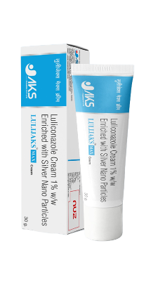
PRODUCT NAME: Lulijaks Max
INCI: Luliconazole Cream 1% W/W Enriched with Silver Nano Particles

- DESCRIPTION:
Luliconazole is an imidazole type antifungal medication approved by FDA for the treatment and management of Fungal infections over scalp, hair, skin, hands, feet or groin area. Luliconazole has low solubility and poor penetration which limits it’s therapeutic application.
Lulijaks max 1% w/w enriched with silver nano particles combats the problems persisting with conventional formulation of Luliconazole

Key Benefits:
- Higher penetration
- Offer broad band protection against Tinea infections
- Higher clinical efficacy
- Nano-encapsulation
- Enriched with silver nano particles
- Offers anti-microbial and anti-inflammatory actions

PACKAGING: Tube
COMPOSITION: Luliconazole with silver nano particles

INDICATIONS:

Covers broad spectrum of Tinea infection

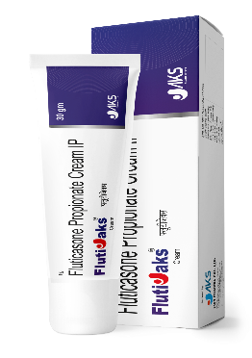
PRODUCT NAME: FLUTIJAKS
INCI: Fluticasone Propionate

- DESCRIPTION:
Fluticasone is a potent steroid that helps reduce inflammation in the body. Fluticasone topical (for the skin) is used to treat the inflammation and itching caused by eczema or skin conditions that respond to steroid medication. Fluticasone has vasoconstrictive, anti-inflammatory & anti-pruritic effect on skin. Fluticasone propionate is safe and effective over the delicate areas of face with:

–> High Potency: Potent corticosteroid with high anti-inflammatory action.

–> Targeted action.

–>Faster relief from symptoms like itching, redness & scaling in eczema, vitiligo and psoriasis

–> Favourable safety profile for topical use

PACKAGING: Tube
COMPOSITION: Fluticasone Propionate

INDICATIONS:

In the management of Atopic Dermatitis, Vitiligo, Psoriasis

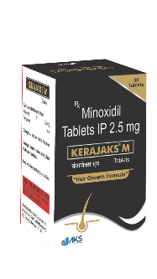
PRODUCT NAME: KERAJAKS M
INCI: Minoxidil 2.5 mg Scored Tablets

- DESCRIPTION:

KERAJAKS M contains Minoxidil 2.5 mg, an orally administered hair growth stimulant, formulated for the management of androgenetic alopecia (AGA) and pattern hair loss in both men and women. It is a systemic alternative to topical formulations, offering convenience and consistent absorption.
✅ Clinically Proven Formula – Stimulates hair follicles & supports regrowth
✅ Scored Tablet for Precision Dosing – Easy to split for customized therapy
✅ Boosts Hair Regrowth from Within – Enhances scalp blood circulation
✅ Non-Invasive Oral Therapy – Convenient & effective alternative to topical solutions
✅ Reduces Hair Thinning & Shedding – Strengthens hair strands & extends the growth phase
✅ Shows good clinical efficacy & safety profile

PACKAGING: 1 * 30 TABLETS IN BOTTLE
COMPOSITION: MINOXIDIL 2.5 MG

INDICATIONS:

Androgenetic alopecia, Telogen effluvium, Post partum and post menopausal hair thinning

PRODUCT NAME: RELUMIA
COMPOSITION:
Opitac® L-Glutathione 500 mg (Japan) + Amla-based Vitamin C 1000 mg + Curcuminoids + Zinc + Vitamin D3

DESCRIPTION:

An Advanced Skin Brightening & Antioxidant Solution
RELUMIA is a scientifically formulated nutraceutical designed to target dull skin, uneven tone, and pigmentation caused by oxidative stress, UV exposure, pollution, and lifestyle factors.
- Opitac® L-Glutathione (500 mg, Japan) – Inhibits tyrosinase activity and shifts melanin towards a brighter skin tone with sustained plasma activity up to 120 minutes.
- Amla-based Vitamin C (1000 mg) – Enhances glutathione action and provides powerful antioxidant support.
- Curcuminoids – Help reduce inflammation and oxidative damage linked to pigmentation.
- Zinc – Supports skin repair, healing, and barrier function.
- Vitamin D3 – Promotes healthy skin function and overall skin wellness.

Additional Benefits:
- Chocolate-coated tablet
- Sugar-free formulation
- Once-daily dosage
- No belching for better patient compliance
Result: Brighter, healthier, radiant skin with improved tone, reduced pigmentation, and enhanced glow from within

INDICATIONS:
- Dull Skin & Uneven Skin Tone
- Hyperpigmentation
- Melasma
- Oxidative Stress-related Skin Damage
- Skin Brightening Support
- Antioxidant Support
- Overall Skin Health & Glow
PRODUCT NAME: FLUTIJAKS LOTION
COMPOSITION:
Fluticasone Propionate + Moisturizing & Skin-Soothing Base

DESCRIPTION:

An Advanced Anti-Inflammatory & Skin Relief Lotion
FLUTIJAKS LOTION is specially formulated to provide rapid relief from inflammatory skin conditions such as itching, redness, irritation, and allergic skin reactions while maintaining skin hydration and comfort.
- Fluticasone Propionate – A potent topical corticosteroid that effectively reduces inflammation, redness, itching, and irritation associated with various dermatoses.
- Skin-Soothing Base – Helps calm sensitive and irritated skin while supporting skin barrier protection.
- Moisturizing Action – Maintains skin hydration and prevents excessive dryness during treatment.

Benefits:
- Fast relief from itching & redness
- Reduces skin inflammation and irritation
- Helps restore skin comfort
- Smooth, non-greasy lotion formulation
- Easy application with better spreadability
Result: Calm, soothed, and healthier-looking skin with effective relief from inflammatory skin conditions.

INDICATIONS:
- Eczema
- Dermatitis
- Allergic Skin Reactions
- Itching & Redness
- Inflammatory Skin Conditions
- Dry & Irritated Skin
- Scalp psoriasis / Dermatitis

PRODUCT NAME: CLINDERA-N GEL
COMPOSITION:
Clindamycin + Nicotinamide Gel

DESCRIPTION:

Next Gen Acne Repair Therapy
CLINDERA-N GEL is a scientifically formulated combination therapy designed to effectively manage acne, acne marks, inflammation, and oily skin while improving overall skin clarity.
- Clindamycin – A topical antibiotic that helps control acne-causing bacteria and reduces inflammatory acne lesions.
- Nicotinamide (Niacinamide) – Helps reduce inflammation, regulates excess sebum production, and supports skin barrier repair while improving skin texture and tone.

Benefits:
- Helps reduce pimples & acne lesions
- Controls acne-causing bacterial growth
- Reduces redness & inflammation
- Helps minimize post-acne marks
- Controls excess oil secretion
- Non-greasy, easy-to-apply gel base
Result: Clearer, smoother, and healthier-looking skin with reduced acne and improved skin texture.

INDICATIONS:
- Acne Vulgaris
- Inflammatory Acne
- Acne Marks
- Grade I to Grade II Acne Vulgaris
- Redness & Skin Irritation Associated with Acne
窗体顶端

窗体底端

5

窗体顶端

